EGR2312 Lab Experiment N°4
Mechanical Analysis of a Signpost

- Objective
In this experiment, you will perform some tasks of a mechanical engineer: modelling, testing, and analyzing the product of a client. Your client is a company that produces signposts that hold billboards (see figure 1).
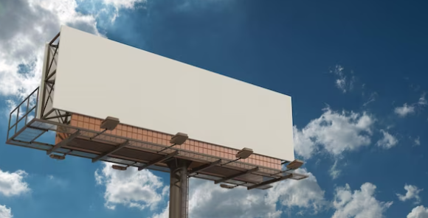
Figure 1. Signpost from your client’s company
Your client wants to put their signposts in a new location that is particularly windy. Your task is to see whether the signposts will be able to handle this new environment by modelling them on ANSYS Mechanical.
- Reminder: steps for a computer simulation:
- Defining the problem: which type of simulation to use? What library of materials? Etc.
- Pre-processing: creating your 3D CAD model and meshing.
- Solving your model: setting the constraints on your 3D CAD model and the setting up the solver.
- Post-processing: visualizing the results computed by the solver.

- How to proceed?
- Defining the problem:
- The signpost is composed of
  - Steel post: cuboid with dimensions w*h1*t
  - Sign: cuboid on top of the steel post with dimensions L*h2*t

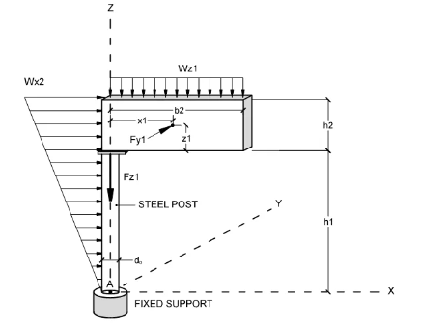
t
SIGN
w
L
Figure 2. Dimensions of the signpost

Where: L = 4m, h1 = 8.5m, t = 0.5m, h2 = 2.5m, w = 0.5m
All parts of the signposts are in structural steel.

- Pre-Processing
The signpost is subjected to the following loads:

Figure 3. Loads
Where:
Wz1 is the mass per unit length of the sign = 1340 N/m,
Wx2 is spatially variable wind load in the x-direction = 700*z N,
Fy1 is the wind force in the y-direction = 3600 N
Fz1 is the weight of the support = 11000 N.

- Solving the model and Processing:
- Generate the stress, strain, and deformation results. Take screenshots.

- Preparing your lab report
- What are the maximum values of stress, strain, and deformation? Where are they located? Insert your screenshots.
- Is your signpost structurally safe? Is it in the elastic or plastic region?
- What recommendations would you make to your client to increase the safety of the signpost?

